**Utilize Scrap Recycling for Better Lean Manufacturing**

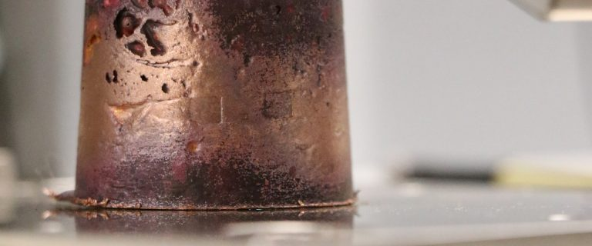

Materials research for efficiency has long been a love affair in American manufacturing. Manufacturers have turned to production theories like Lean Manufacturing to save time, money, and produce higher-quality products.

The only issue?

Almost no one is making use of their waste materials.

**The Goal of Manufacturing Waste Management**

Lean Manufacturing is a method of minimising waste at every stage of the manufacturing process. Lean Manufacturing, often known as the Toyota Production System, was developed by Toyota to reduce costs and improve product design in order to maximise profits.

The concepts of Six Sigma and MVP (Minimum Viable Product) are similar. The purpose of each of them is to build a waste management system for your industrial process.

For safety and to speed up production, scrap debris is frequently pushed aside, both figuratively and physically. But what if there was a way to get more out of it?

**It's Important to Gather and Dispose of Scrap Properly**

Whereas swarf and chips can put your manufacturing line in jeopardy if left uncontrolled, the collection procedure can increase your costs. When scrap garbage is gathered and packaged for recycling, it reduces the amount of time it takes to get it picked up and sold to a metals recycler.

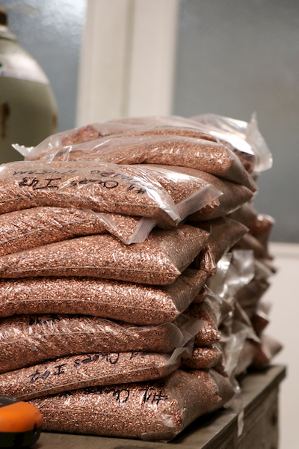

The time cars are in your loading bay can slow down your delivery time in an organisational plan where distance and travel time count on the production line. For Direct To Consumer (DTC) Product Manufacturers, loading-bay procedures are even more crucial.

When competing against Amazon's two-day shipping cycle, the time spent moving scrap for sale is important to accomplishing one of Lean Manufacturing's basic rules: enhance the flow stream.

**Your Improvement Process Could Be Revolutionized By Remanufacturing**

Despite the fact that the concept has been known for decades, few American manufacturers have taken advantage of the scrap remanufacturing process. You can use remanufacturing to cut material costs when innovating to suit new market demands.

This method is already being developed in the most unlikely of places: the fashion industry.

Remanufacturing is used by brands like Zara, Supreme, and H&M to slash production costs and compete with new trends at breakneck speed.

**Cost Control at Both Ends of the Supply Chain**

The success of these brands can be attributed to their Lean Manufacturing and supply chain management. They use textile recycling and remanufacturing to provide for lightning-fast operation time outside of the production line.

Textile recyclers then use these scraps of natural and synthetic fabric to make new material, rags, and plastic wire covers. The firm then goes back to the textile recycler to purchase recycled cloth at a lower cost than they might elsewhere.

**Metals Recycling Makes It Even Easier**

Although some manufacturers are aware that they can obtain cheaper metals, they are frequently concerned about the quality of metals obtained from recyclers, despite the fact that the metals have been accurately graded. Others don't want to waste time trying to come up with innovative ways to dispose of their scrap metal.

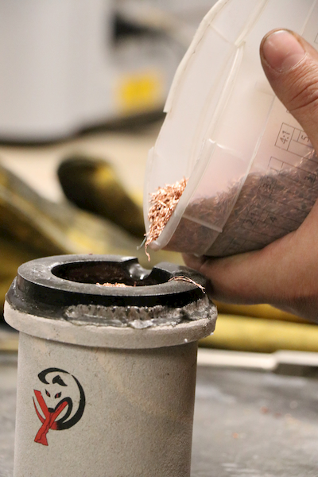

Since the first arc reactor in the 1800s, metal recycling has gone a long way. Recycled goods are now definitely comparable to newly mined metals in terms of quality. Steel is 100 percent recyclable, whereas ores like aluminium, copper, and titanium must be recycled thousands of times before they lose their purity.

**Trade and manufacturing organisations have backed it up**

The United States International Trade Commission (USITC) and REMADE, a manufacturing USA Institute supported by the US Department of Energy, have stepped in to help.

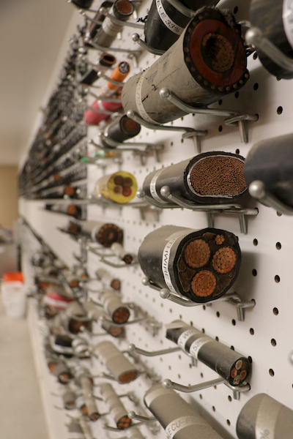

The USITC discovered that companies using remanufacturing reused 50-90 percent of their original product material without using Lean Manufacturing or Six Sigma techniques. So this method must be used by everyone to save money, right?

They discovered that remanufacturing accounted for only 2% of overall market sales.

**The Department of Energy is urging you to develop new technologies**

REMADE was founded to ensure the future of the manufacturing industry in the United States by utilising new technology and practises. The organisation is a public-private collaboration that aims to assist firms in improving their design processes in order to compete in the global market.

The same country that transformed industry by developing the assembly line is in danger of losing the technological advantage it has enjoyed for years. You'll need to secure your Manufacturing Waste Management to stay inside budget.

**You Aren't on Your Own**

[Recycle Pro](https://www.recyclepro.co.uk/), a national Ewaste recycler, has assisted a number of businesses in securing logistics and transportation for their Ewaste while also lowering manufacturing costs.